Software Requirements Specification Template

Paddle My Way

Software Requirements Specification

Version 1.0

11/13/2022

Nikhila Chowdary Vaitla(S546518)

Padmavathi Maddukuri(S546956)

Manoj Kumar Barugu(S546292)

Pranay Kumar Pavuluri(S546959)

Kousalya Dasari(S546651)

Lakshmi Prathyusha Bavanam(S546663)

Submitted in partial fulfillment

Of the requirements of

CSIS 44-691 Graduate Directed Project 1

# Revision History

|  |  |  |  |
| --- | --- | --- | --- |
| **Date** | **Description** | **Author** | **Comments** |
| <date> | <Version 1> | <Your Name> | <First Revision> |
|  |  |  |  |
|  |  |  |  |
|  |  |  |  |

# Document Approval

The following Software Requirements Specification has been accepted and approved by the following:

|  |  |  |  |
| --- | --- | --- | --- |
| **Signature** | **Printed Name** | **Title** | **Date** |
|  |  |  |  |
|  |  |  |  |
|  |  |  |  |

**Table of Contents**

**Table of Contents Page Number**

1. Introduction
   1. Purpose
   2. Scope
   3. Definitions, Acronyms, and Abbreviations
   4. References
   5. Overview
2. General Description
   1. Product Perspective
   2. Product Functions
   3. User Characteristics
   4. General Constraints
   5. Assumptions and Dependencies
3. Specific Requirements
   1. External Interface Requirements
      1. User Interfaces
      2. Hardware Interfaces
      3. Software Interfaces
      4. Communications Interface
   2. Functional Requirements
   3. Use Cases
   4. Class/Objects
   5. Non-Functional Requirements

3.5.1. Performance

3.5.2. Reliability

* + 1. Availability
    2. Security
    3. Portability
  1. Inverse Requirements
  2. Design Constraints
  3. Logical Database Requirements
  4. Other Requirements
  5. Prototypes (for complete project)
  6. Use Case Diagrams

1. Design

4.1. ER diagram

4.2. GUI

1. Analysis Models

5.1. Data Flow Diagram

5.2. Sequence Diagram

5.3 Implementation Components

6. User Manual

6.1 Launching Application

6.2 Login/Register

6.3 Forgot Password

6.4 Global Search

6.5 Live Chat

6.6 Filtering of Data

6.7 Calendar in Wishlist Screen

6.8 Ratings and Reviews

6.9 Payment Getaway

6.10 History of Trips

7. Technical Manual

7.1 Targeted Audience

7.2 Purpose

7.3 Scope

7.4 Software Installations

7.5 List of packages in project

7.6 Side Navigation Bar

7.7 Chat Model

8. Conclusion

**1. Introduction**

**1.1 Purpose**

In this project a detailed review of the tour and travels management system. The main objective of this application is to provide the best travel destinations for travelling based on the factors like no. of people and season. Searching will be very easy as it asks the user to enter the details. At a single click the user will be able to fetch the required data. This project will provide the relevant information about description about the places. This Paddle My Way (Tour & Travel) system will be helpful for people who are planning to travel.

**1.2 Scope**

The main scope of the project is described below

* The project's main purpose is to give information about places which travelers want to visit and provide features to find nearby famous tourist spots, restaurants etc.
* In this project we include exclusive features to give the best mode of transportation, no. of places to visit and budget calculation based on number of people and season chosen by the user.
* It also includes extended features like updated information of the places, generating reviews based on the travel experience and photos uploaded by the user.

**1.3 Overview**

Our project is about travel planning where the user must sign up and then login to find budget-friendly places. Following the selection of the region, the user must specify the season, budget, departure date, and number of people. This application provides a list of places to visit along with the description of the place in that region. Based on the Wishlist of the travel i.e., amusement parks, museums, cruise tours etc total estimated budget for the travel will be calculated. This will also have features to add the mode of transport and accommodation details which will be redirected to the respective sites. The user can enter the booking details for the total trip. The user can also provide reviews of the places after their travel. The user will also be able to view their previous and upcoming travel bookings.

**2. General Description**

In our project, we are developing an IOS application where users need to sign up and then login to the application to find the budget friendly places. Once the user selects the region, they will need to select the season they are planning to travel, budget, date of departure and no. of people. Based on their requirements for the plan, the application will provide details like types of Transportation for the trip, best places to visit nearby, best season to visit the place, total no. of days of the plan, type of accommodation, nearby restaurants, and reviews of the places. The user will also be able to look at their past travel bookings, upcoming bookings.

**3. Specific Requirements**

**3.1. External Interface Requirements**

We will be having external websites like different airways, accommodations, restaurants containing the information.

**3.1.1. User Interfaces**

We are designing a user interface with the help of Swift Language.

**3.1.2. Hardware Interfaces**

1. Operating System (32- or 64-bit iOS)
2. Processor (1 dual core or single core processor)

**3.1.3. Software Interfaces**

XCODE

**3.1.4. Communications Interface**

The Communication Interface we are using for our project is Appstore.

**3.2. Functional Requirements**

**Customer side: -**

* Ability to sign up/login into the application.
* Ability to search for the tourist place after successfully logging in.
* Ability to view the results from the search list of the application.
* Ability to redirect to the external website based on the provided URL.

**Administration side: -**

* Ability to login in the user.
* Ability to display the requested information from the customer.
* Ability to display the places which the user is referring or searching for.

**3.3. Use Cases**

In this Project the primary goal is to provide all the details such as place and rating of the places and travelling preferences on a single application, which indeed helps the customers to save their valuable time.

**3.4. Class/Objects**

We will create the classes accordingly once we start implementation of the project.

**3.5 Non-Functional Requirements**

**Performance**

Performance is the objective measurement and perceived user experience of a web site or application. This includes the following major areas:

* 1. Reducing overall load time
  2. Making the site usable as soon as possible
  3. Smoothness and interactivity

**Reliability**

In applications, reliability is the main concern. It basically has the factors which make applications strong, usable, mature, and effective. It deals with the rate of failure in applications.

**Availability**

Availability refers to the ability of the users to access and use an application. It is typically communicated as a percentage for a given span of time.

**Security**

Application security refers to a variety of processes, technologies, or methods for protecting such as Apple’s App Sandbox, APIs from attack by Internet-based threats.

**3.7 Design Constraints**

System design is the solution to the creation of a new application. In this phase we focus on the detailed implementation of the building application. It emphasizes translating design specifications to performance specifications. System design has two main phases of development: logical and physical design.

The analyst describes inputs (sources), outputs (destinations), databases (data stores), and procedures (data flows) in a format that meets the user's requirements during the logical design phase. The analyst also specifies user requirements at a level that virtually determines the information flow into and out of the system, as well as the data resources. Data flow diagrams and database design are used to create the logical design in this case.

The physical design is followed by the user interface design and coding. By defining the design specifications, which tell the programmers exactly what the candidate system must do, physical design creates the working system. Programmers create the programs that accept user input, perform necessary processing on accepted data, and generate the required report on paper or on the screen.

**Use Case Diagrams**

**High level Data Flow Diagram**

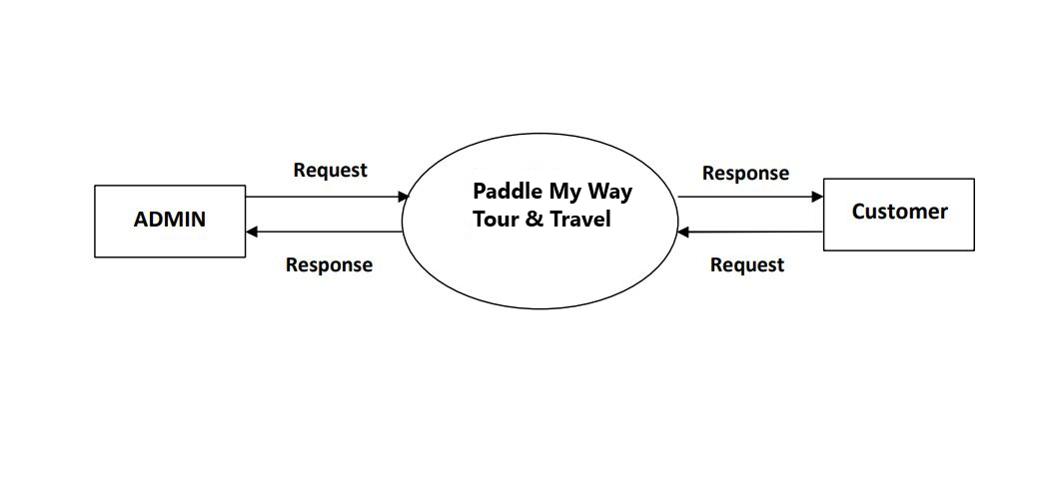

**First level Data Flow Diagram for ADMIN**

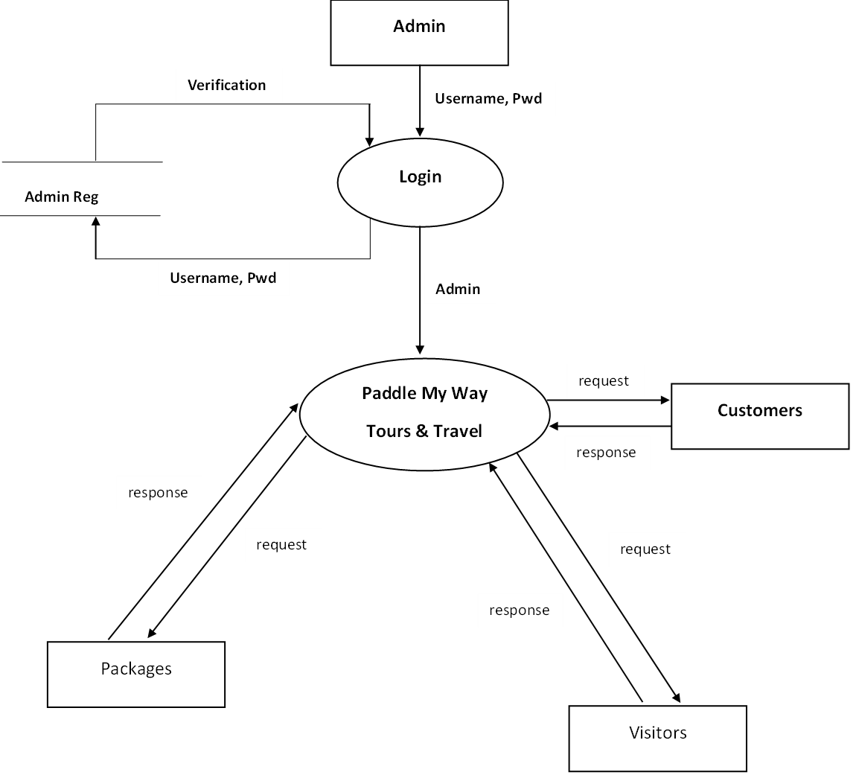

**First Level Data Flow Diagram for Customer**

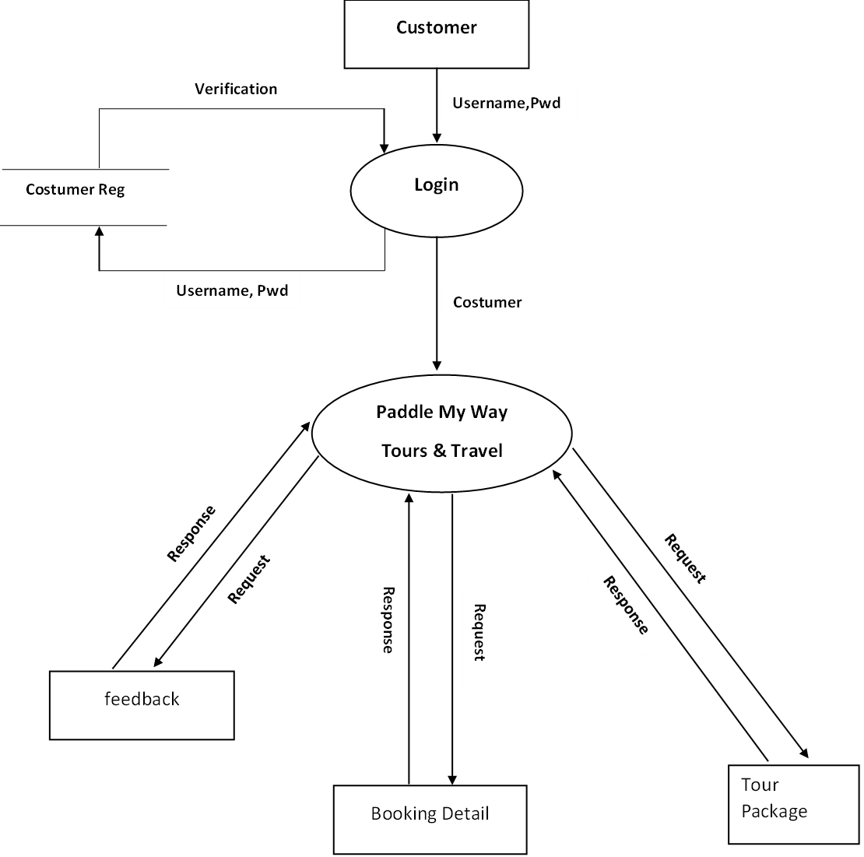

**4. Design**

**4.1. ER Diagram**

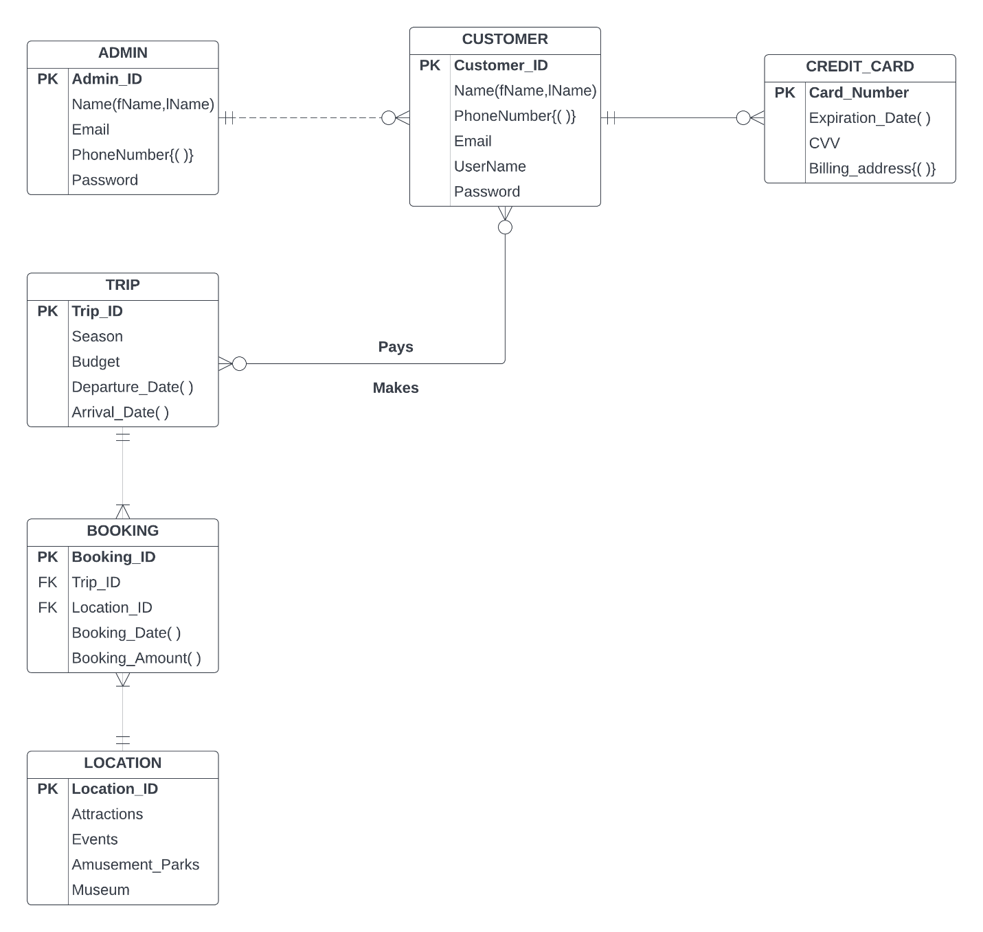

**4.2 GUI:**

**1. Home Screen**

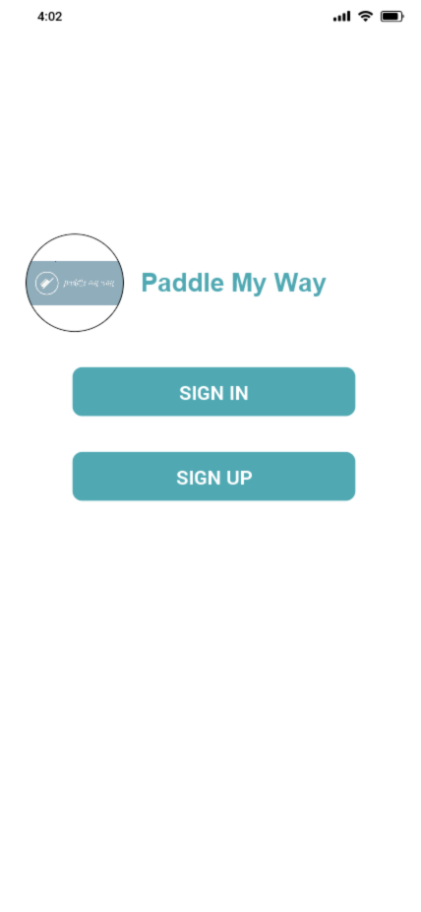

**2.Sign Up Screen**

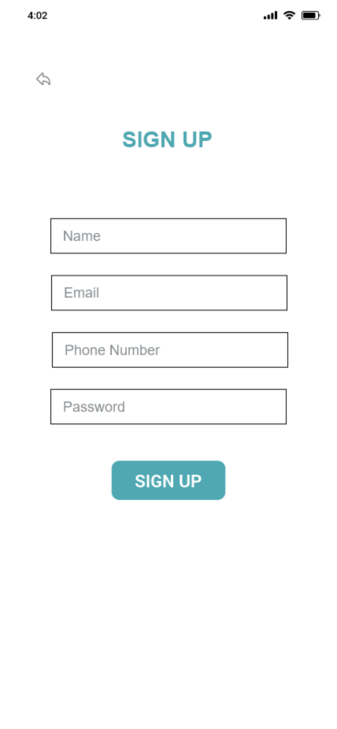

**3.Sign In Screen**

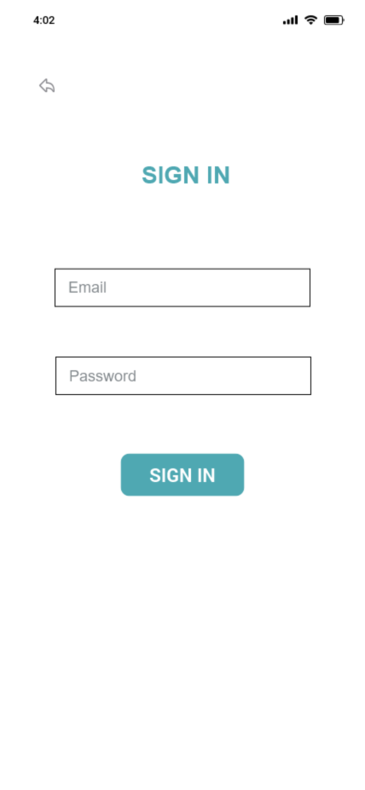

**4.Dashboard Screen**

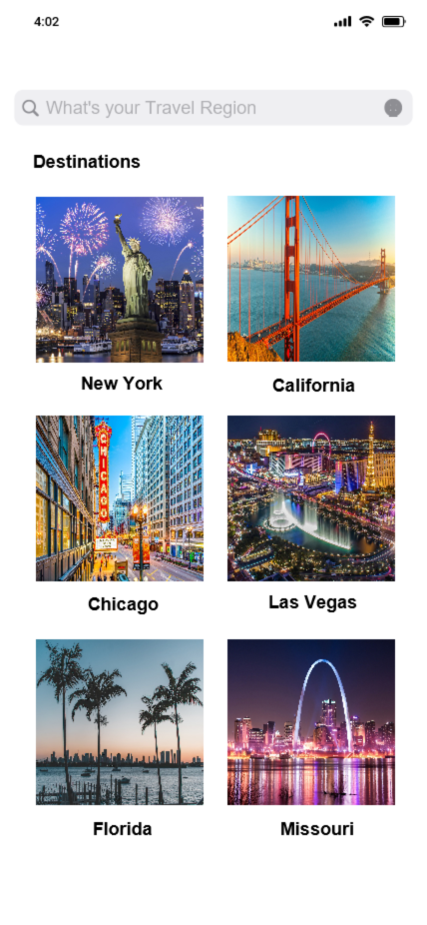

**5.Filter Screen**

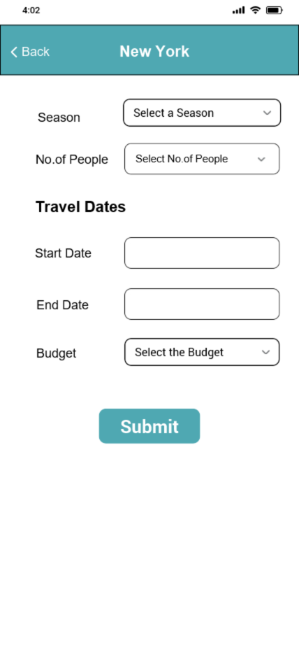

**6.Locations Screen**

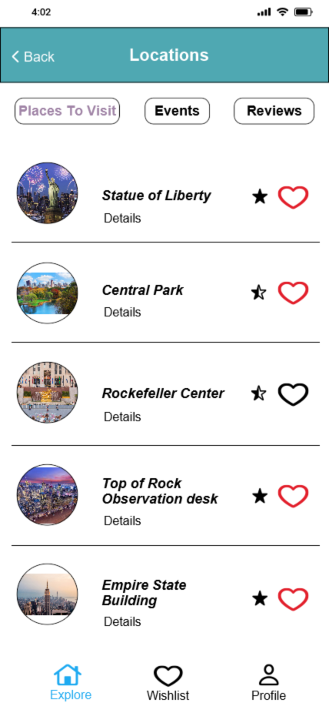

**7.Events Screen**

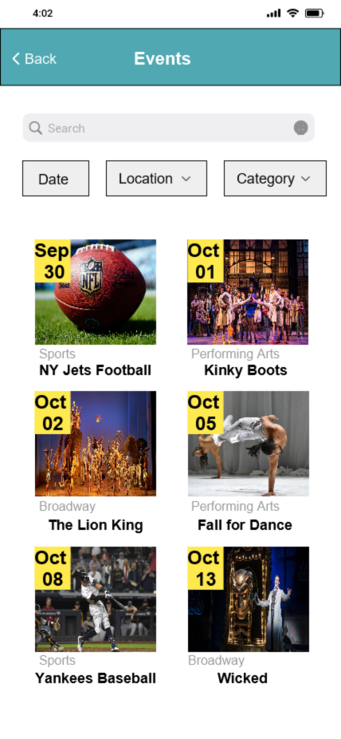

**8.Reviews Screen**

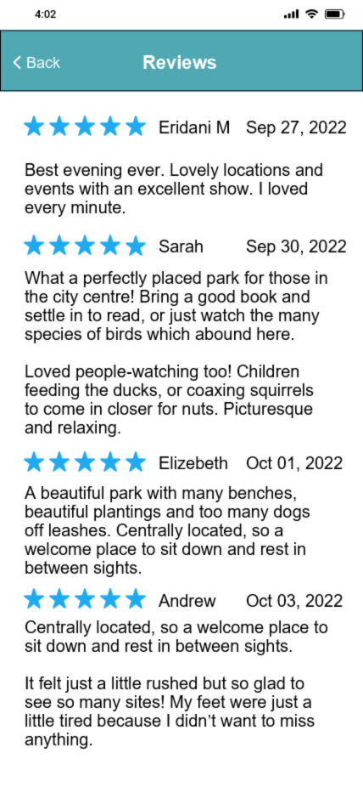

**9.Wishlist Screen**

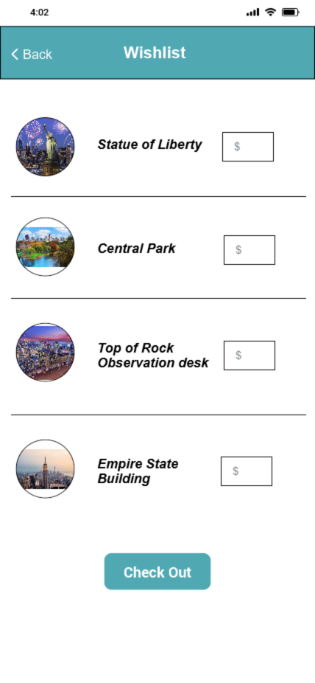

**10.Payment Screen**

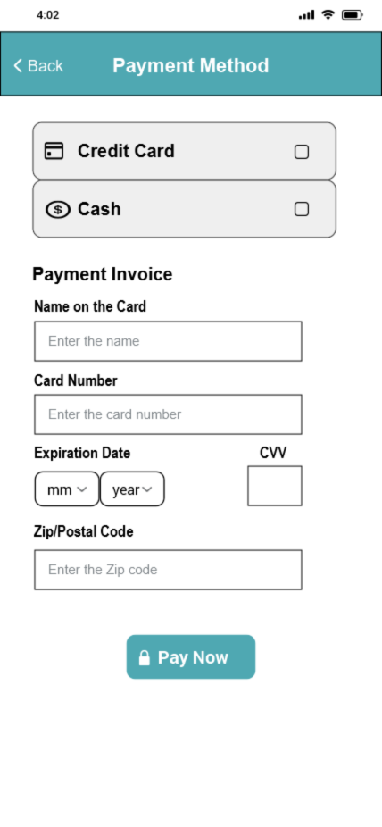

**11.Payment Confirmation Screen**

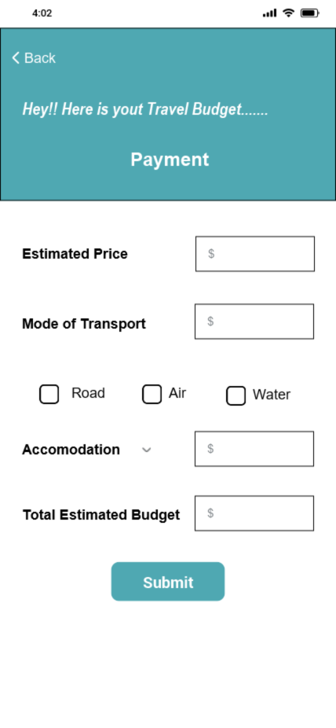

**5.Analysis Model**

**5.1 Data Flow Diagram**

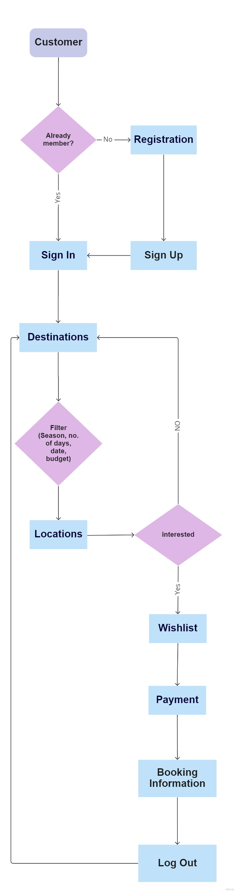

**5.2 Sequence Diagram**

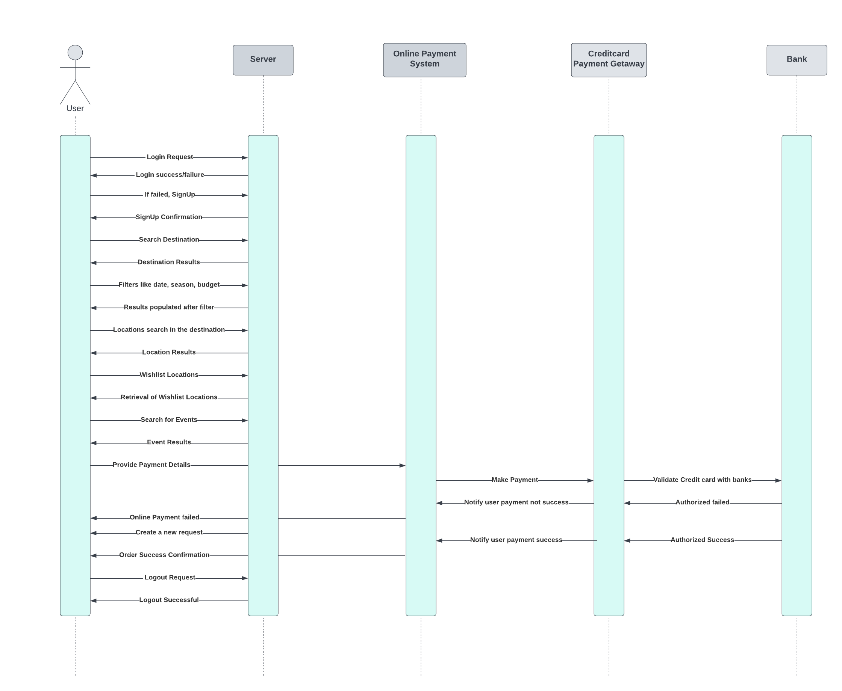

**Implementation Components**

|  |  |
| --- | --- |
| Front End | Swift (Client) |
| Back End | Swift (Backend) |
| Database | Firebase |
| Server | iOS cloud servers |

1. **User Manual**

**6.1 Launching Application:**

Users can launch the application by installing it in the App store.



**6.2 Login/Register:**

Once the users visit the application, they can either Sign In or Sign Up .

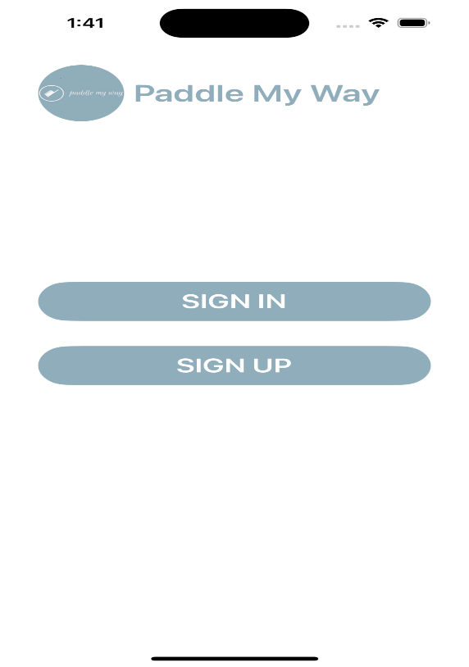

1. If they are already registered with the application, they can choose SignIn and enter their credentials to enter into the application.

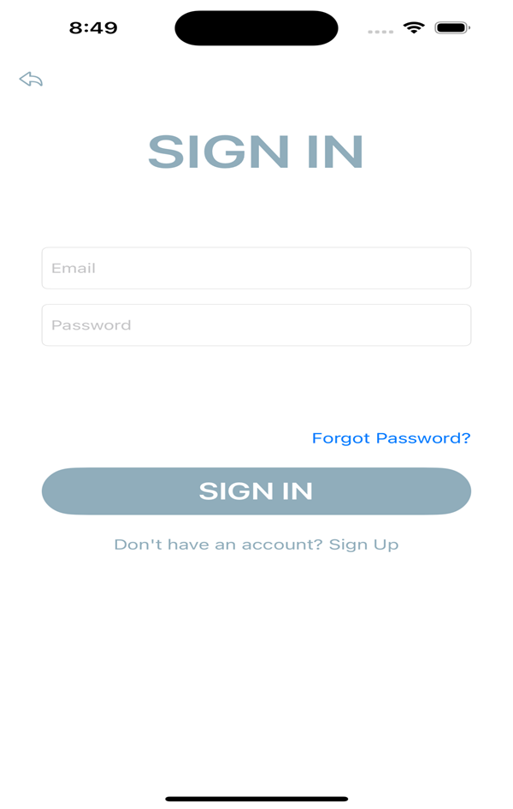

1. If they are new to the application, they can choose Sign Up and get registered with the application.

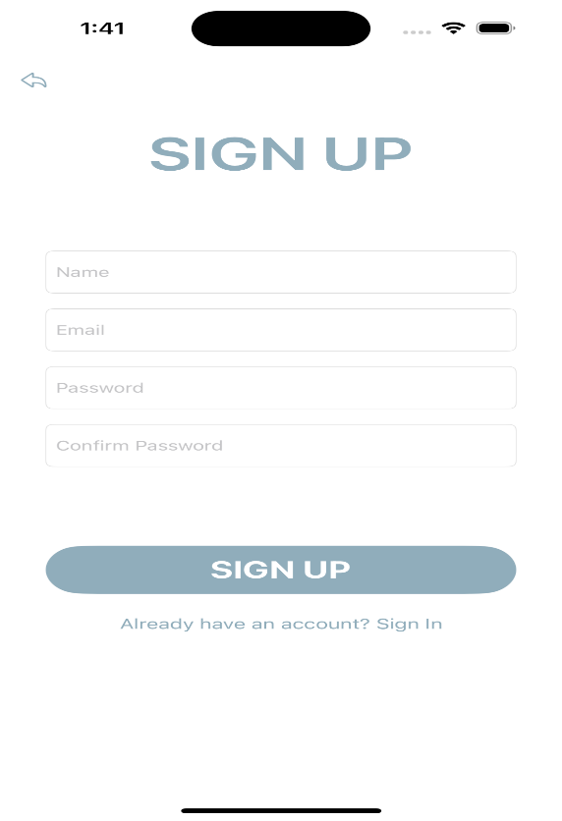

**6.3 Forgot Password:**

If the user has any login issues, like if they forgot their password, they could click on forgot password and enter their registered email id, so that they will receive a mail to reset their password.

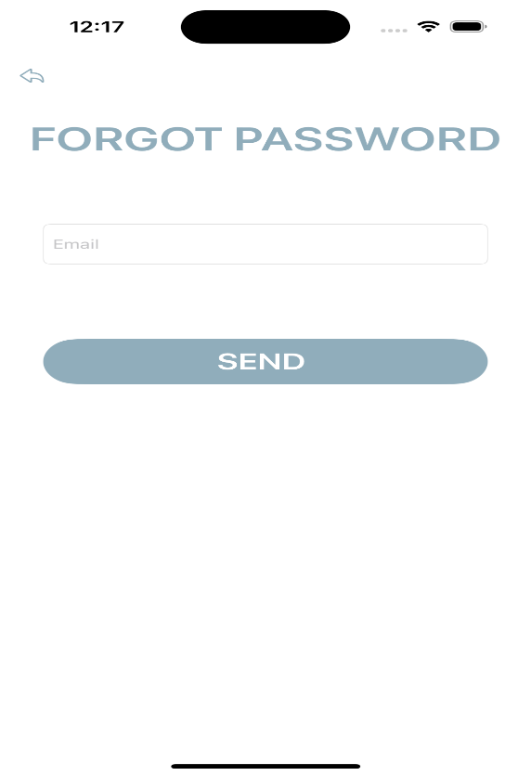

**6.4 Global Search:**

It allows the end users to perform search operations within an application. It searches across multiple forms for records that match a word or phrase that users type in the search area.

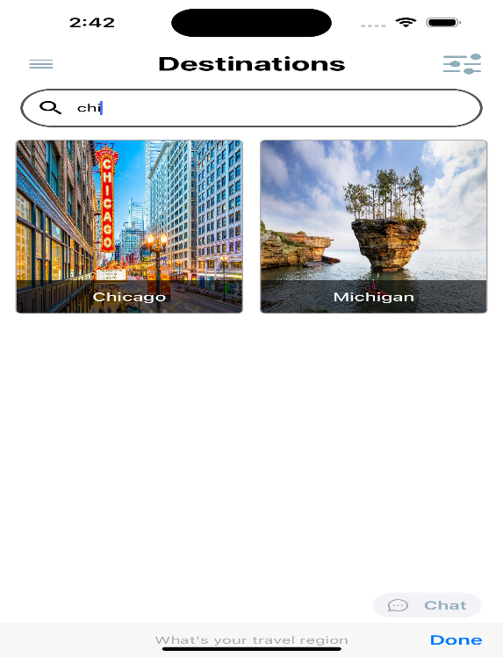

**6.5 Live Chat:**

It allows customers to communicate with customer support representatives in real-time. Customers can chat with you on your application, instead of having to call or send an email.

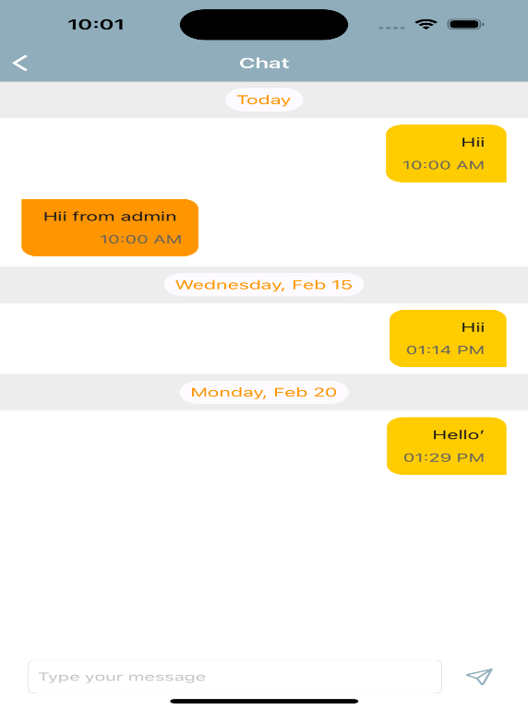

**6.6 Filtering Data:**

It allows you to filter a range of data based on criteria you define. It provides data in a sorted way which helps the user to identify their requirements in a quick manner.

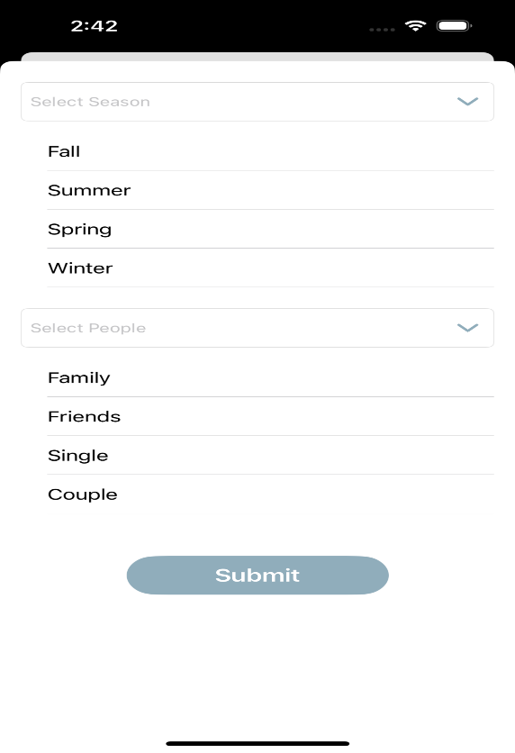

**6.7 Calendar in Wishlist Screen:**

It allows users to directly select the date of their travel directly from the calendar inserted. This helps in identifying the day easily as we can view there itself instead of looking for our own one.

**6.8 Ratings and Reviews of the trip:**

It allows users to provide feedback about their trip. With the reviews provided, other people can view and decide their travel destinations.

**6.9 Payment Getaway:**

It will be the third-party platform used by the applications which allows user to make payment through them. It confirms with the bank about the fraud detection and allows the payment.

**6.10 History of Trips:**

It helps users to find their past and future bookings from the profile screen. This provides information for any people if they want to share their past trip details with their friends.

1. **Technical Manual**

**7.1 Targeted Audience:** As everyone says, no one knows the real thing until they experience. So, this project has come from our own experience. Being students in new places, we have very little knowledge of the various tourist places around us. So, we have built an application considering all these factors which help users in saving valuable time and money.

**7.2 Purpose:** Our project purpose is to build an application which contains all budget friendly places.

**7.3 Scope:** Our project's primary goal is to make it simple for users to utilize our services.

**7.4 Software installations:**

1. Xcode

2. Firebase

**7.5 List of Packages:**

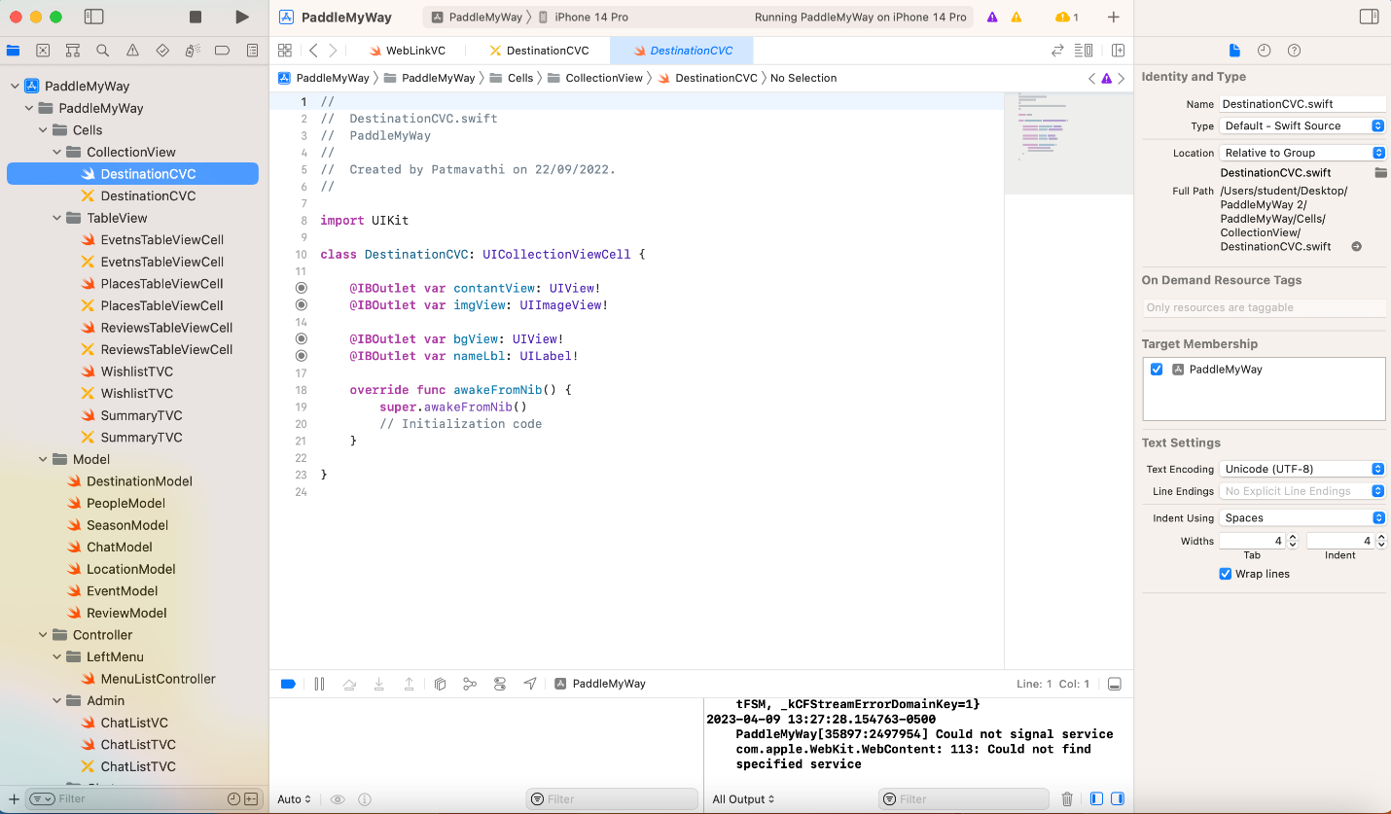

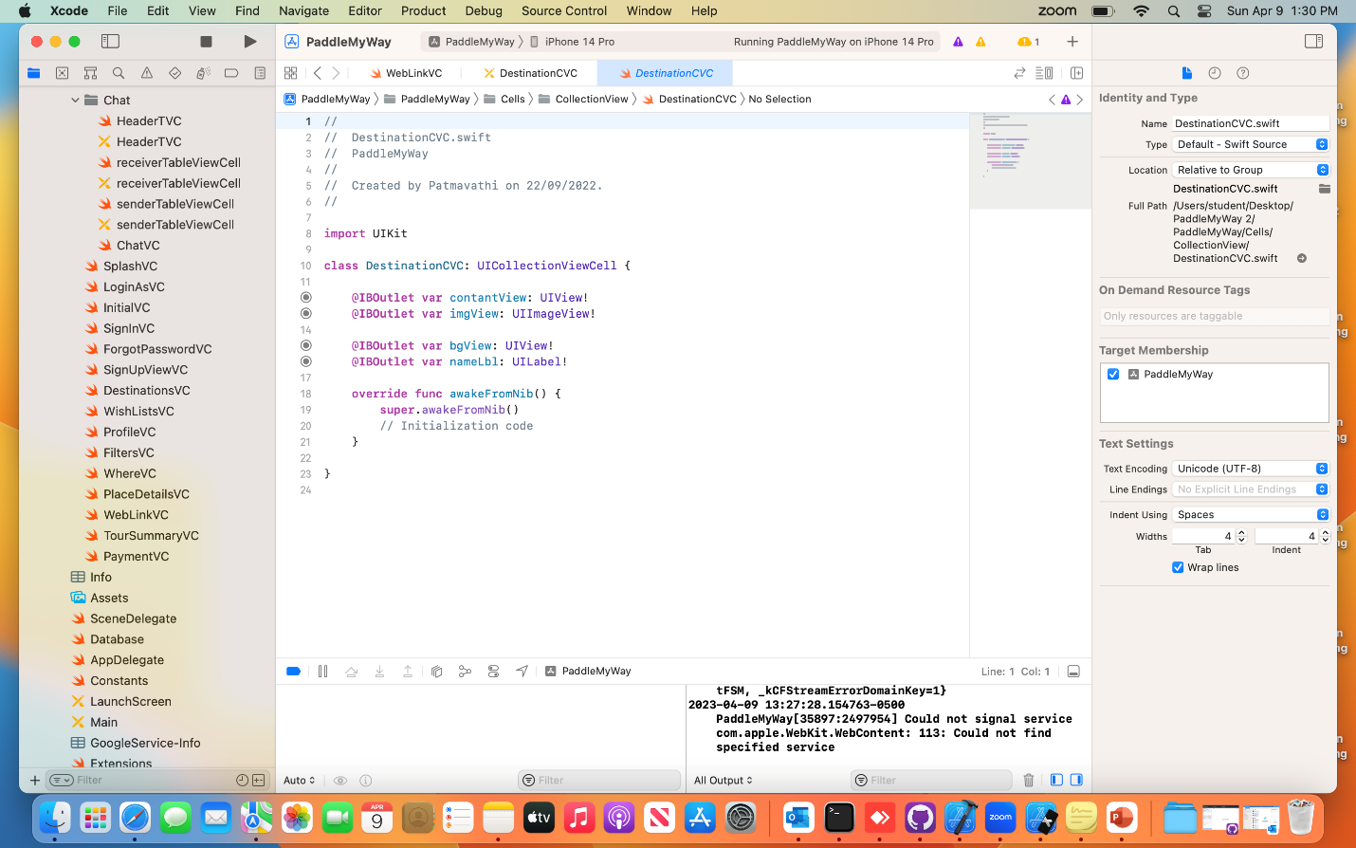

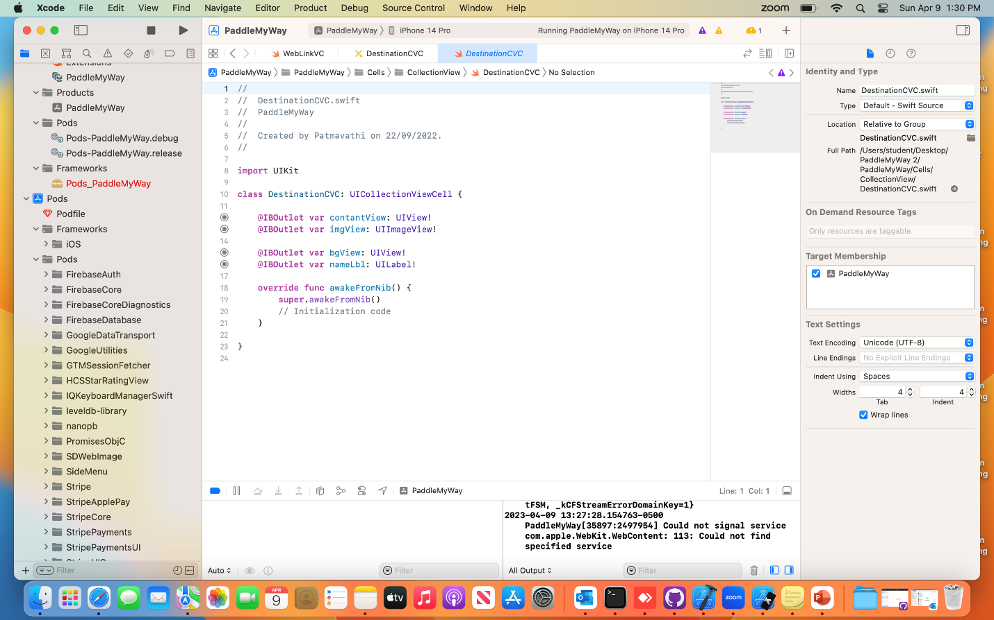

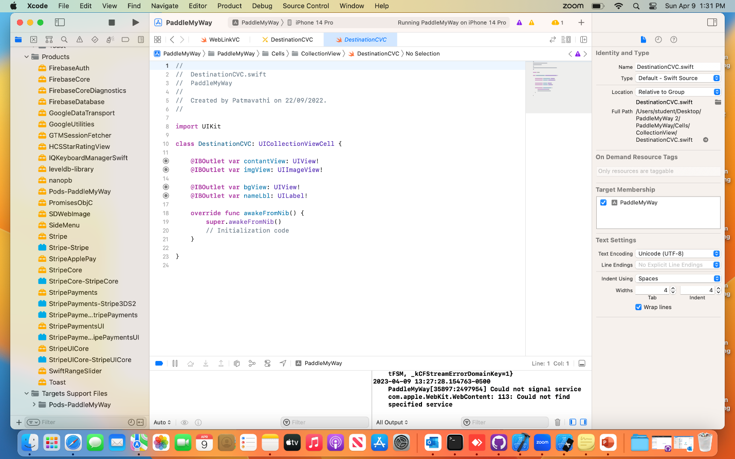

**7.6 Side Navigation Bar:**

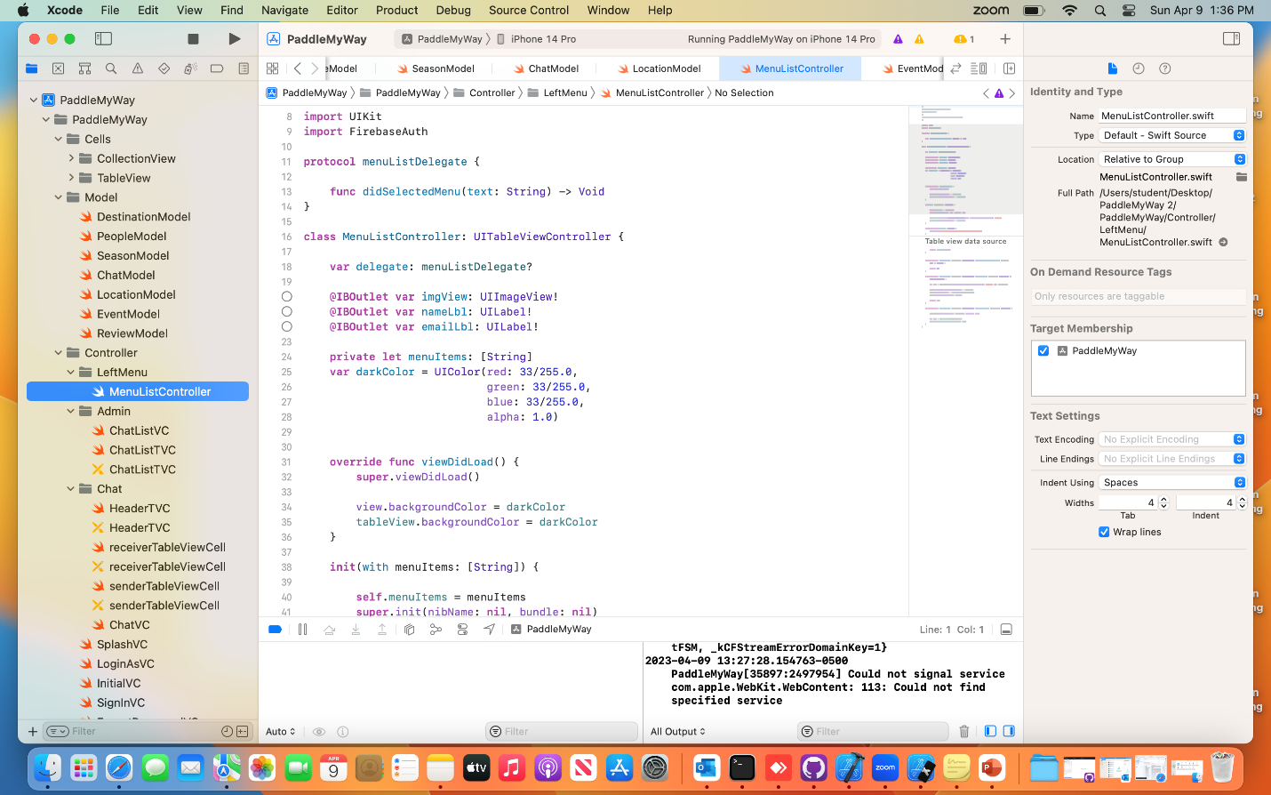

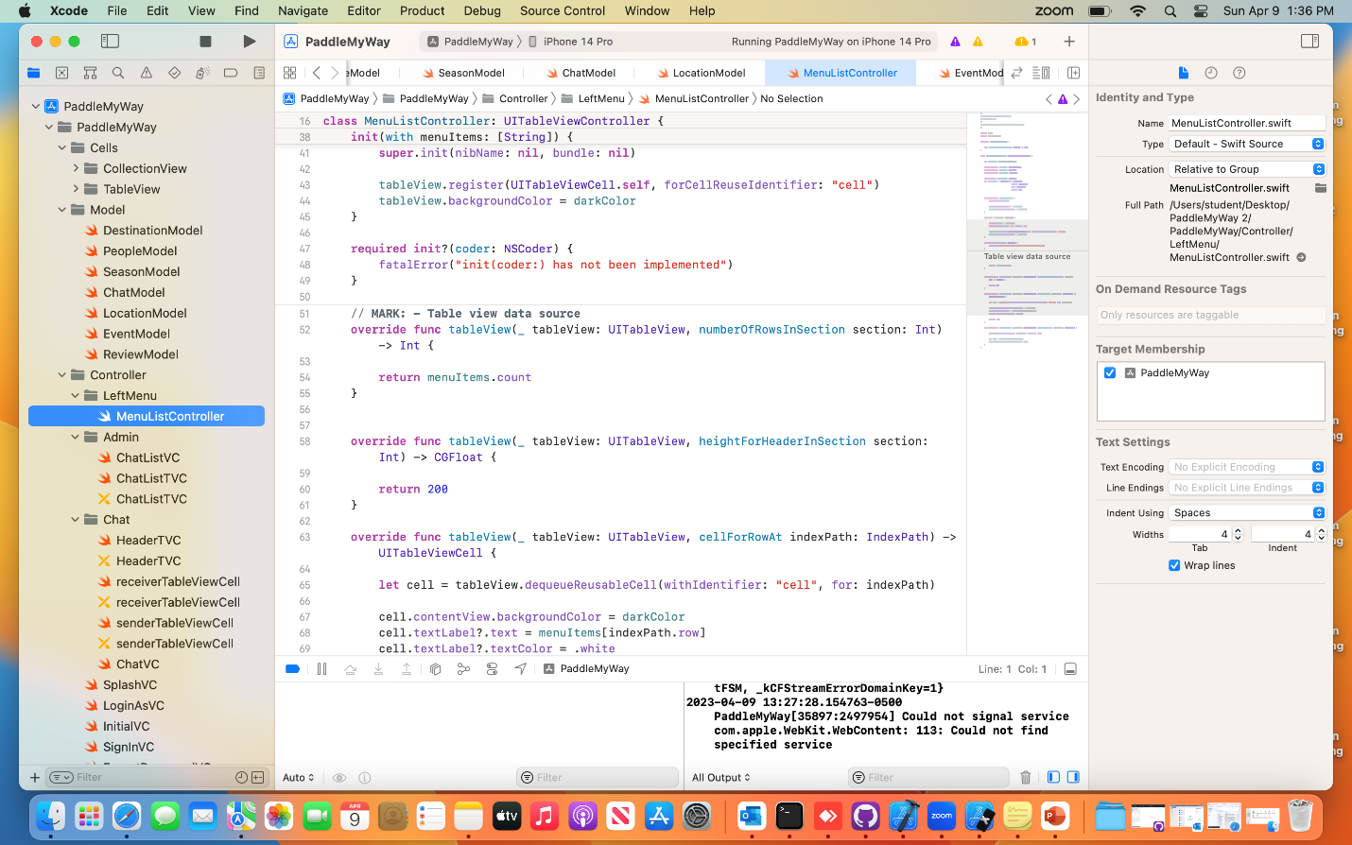

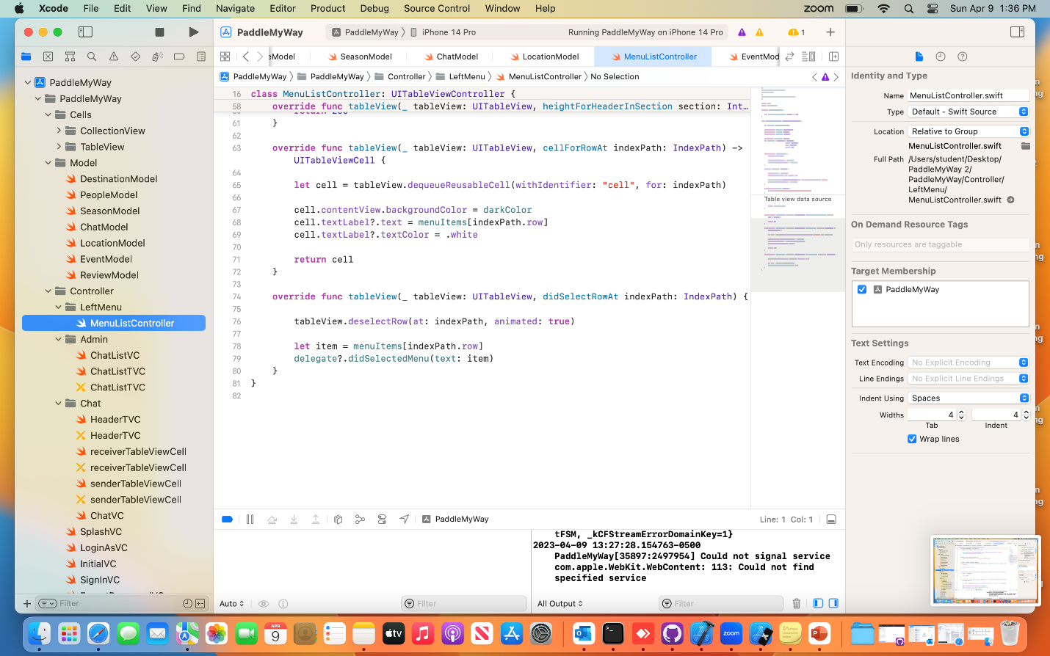

**7.7 Chat Model:**

